**Python Development internship**

**Task**

1. you have to create one ppt file using Python script, with the following requirements.

- Create 2 slide-in single pptx file, - Read content from sample_slide1_input.txt file and add that to Slide1.

- Read content from sample_slide2_input.txt file and add that to Slide2.

- (!important note) You have to use the given sample_font_file.ttf file for all the font styles. - Note that you have to use .ttf file to modify the fonts.

2. Find/Create Font file (.ttf or .woff or .woff2 | html/css supported extension)

- sample_task2.html (there are three maths equations in this html file.)

- you have to modify its font so that it should look handwritten,

- for this, you can find or create (with all maths data support) fonts and use CSS with the given HTML to change the fonts.

!!Important Note For Submission: - For the first screening task upload your output ppt in google drive (share with setting anyone with the like can view.)

- For the Second screening task upload a screenshot of your output html with font change, your maths font and the HTML itself.

**Report**

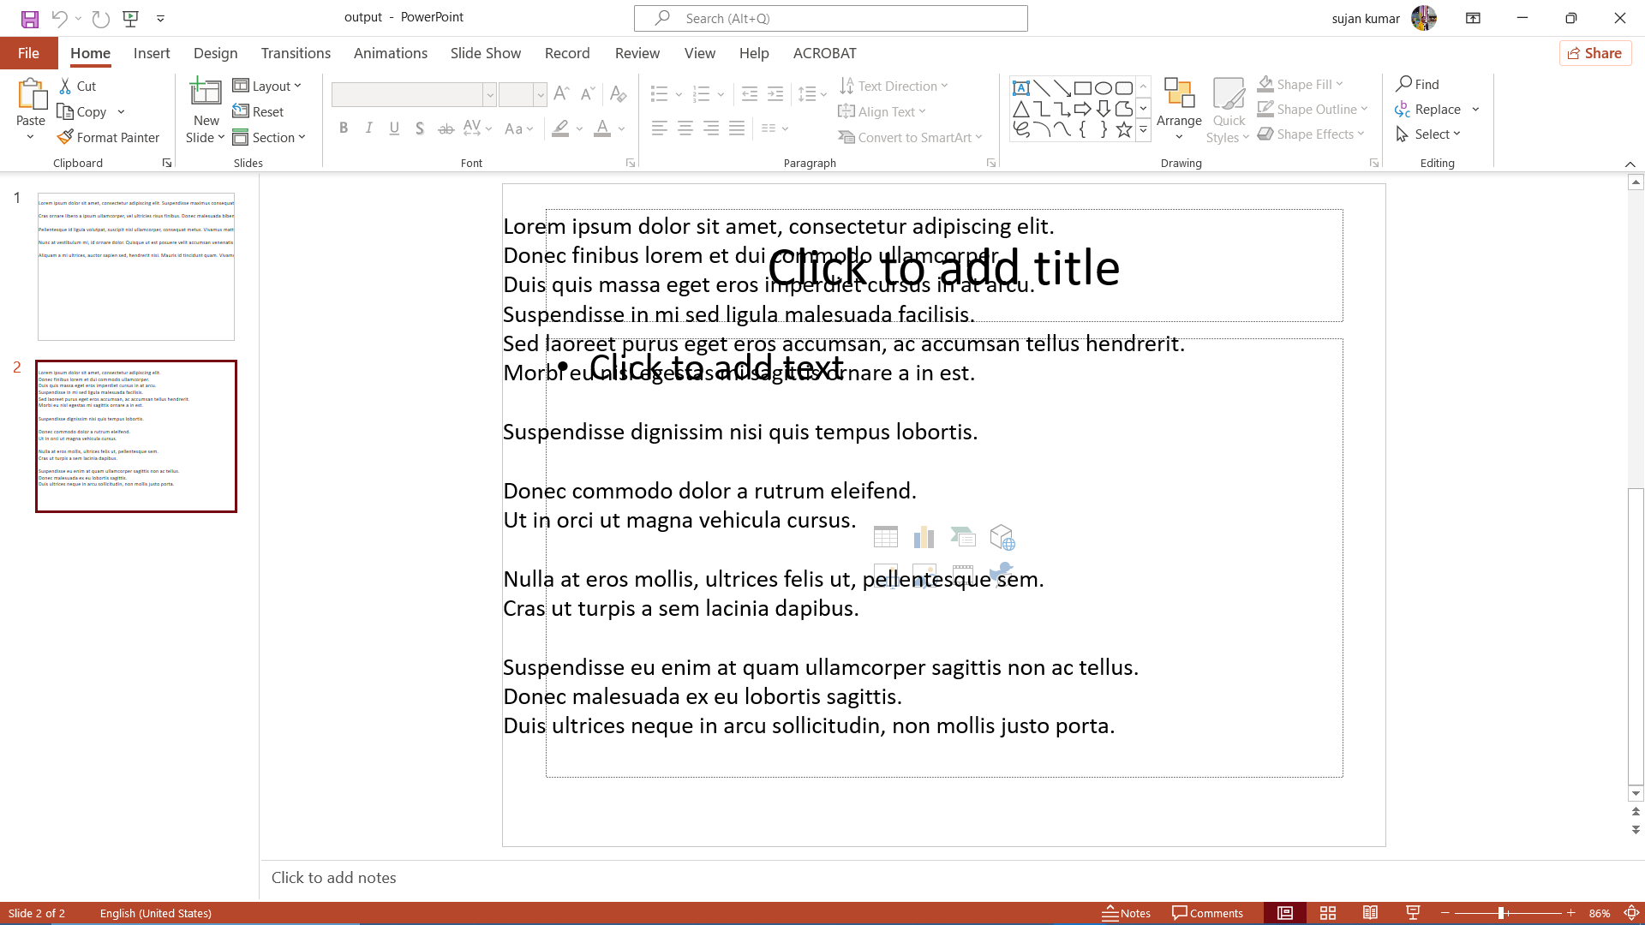

1. We've written a function called add_text_box() in this code that accepts arguments for the slide, location, dimensions, text content, font name, and font size. The text box is added to the slide, and the function controls the text's content, font, and size.

Slides 1 and 2's input text content are declared as variables. Additionally, the font name and size are mentioned. The add_text_box() function is used to add the text boxes with the required parameters after creating a presentation object, adding two slides, and using the selected layout.

The presentation is then saved to the designated output path.

2.

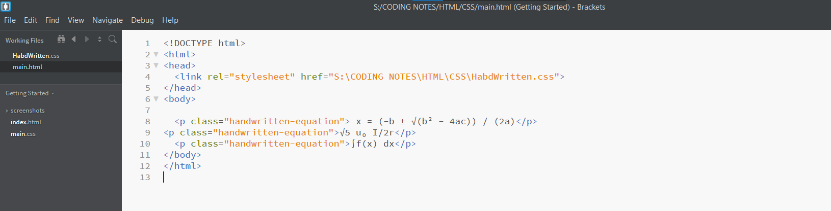

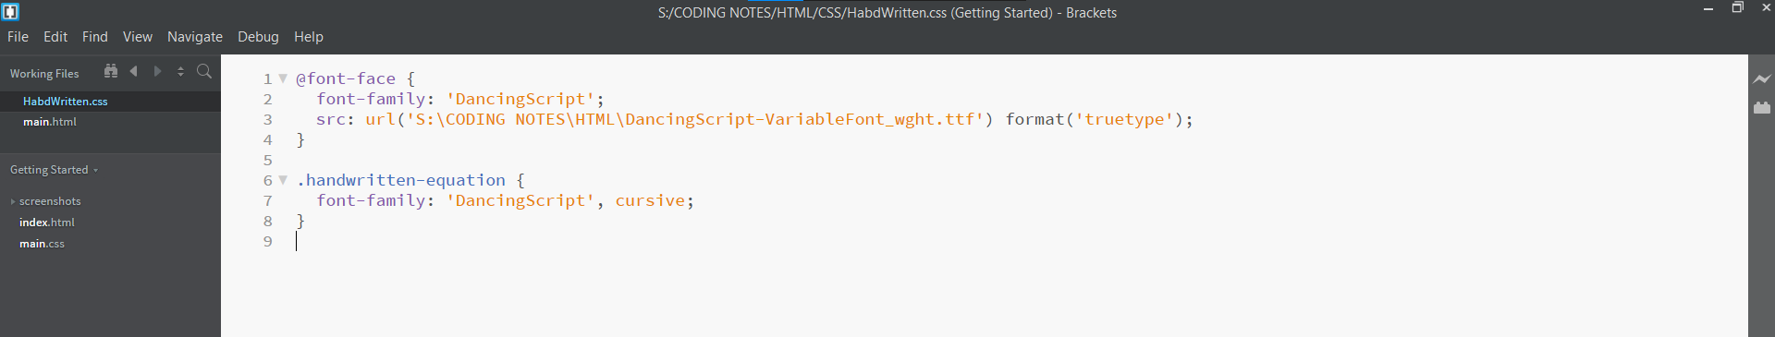

Output:

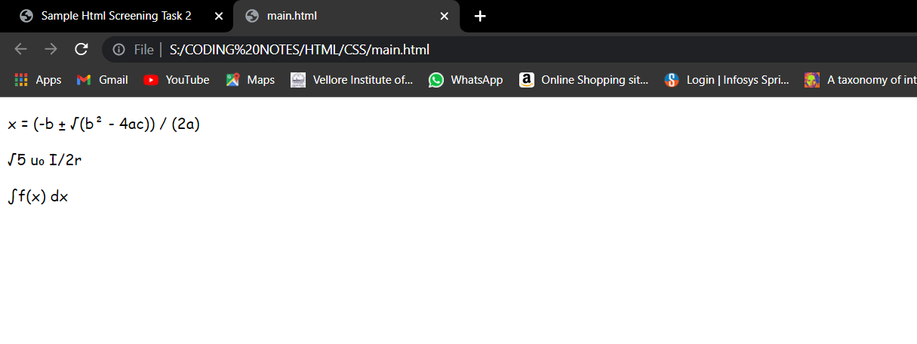

Summary:

Here We concentrated on changing the font of equations in an HTML file to give them a handwritten appearance in the offered solution. CSS (Cascading Style Sheets) and HTML (Hypertext Markup Language) were used as part of the solution to produce the intended outcome.

First, a suitable handwritten font was chosen, one that includes mathematical characters and symbols. The necessary font file, such as one in the.ttf or. Off format, was then downloaded.

The HTML file was then given a CSS file or CSS code. The font-family and the location of the downloaded font file were specified using the @font-face rule. To apply the handwritten font style to the selected equations, a CSS class called "handwritten-equation" was made.

Here We concentrated on changing the font of equations in an HTML file to give them a handwritten appearance in the offered solution. CSS (Cascading Style Sheets) and HTML (Hypertext Markup Language) were used as part of the solution to produce the intended outcome.

First, a suitable handwritten font was chosen, one that includes mathematical characters and symbols. The necessary font file, such as one in the.ttf or. Off format, was then downloaded.

The HTML file was then given a CSS file or CSS code. The font-family and the location of the downloaded font file were specified using the @font-face rule. To apply the handwritten font style to the selected equations, a CSS class called "handwritten-equation" was made.

The output of the changed HTML file displays the equations in a visually pleasing manner while still using the handwritten font. The equations have a handwritten appearance, giving the mathematical phrases a unique touch. The changes result in increased engagement and attractiveness, which improve the user experience as a whole.  
  
Overall, the goal of changing the equations' font and giving them a handwritten appearance is effectively accomplished by integrating the handwritten font using CSS and HTML.

----------------------------------------------Thank You---------------------------------------------